Daniel Williamson

Project #1

2/8/17

EE 222

Project Overview

Purpose:

The purpose of this project was to ask the user for an initial velocity, an initial firing angle and the height from which you launch from. After we gather the information needed from the user we do some calculations to determine how far the projectile will fire and how long it will take tell it lands.

Approach:

To begin, I knew I had to create some variables to hold values from which the user enters it. So then I ask the user for input. I make sure that they are within the bounds of what is prescribed by the instructor. Using a while loop I was able to re-ask the question to make sure it was within bounds. Once the user does input a parameter within bounds it will move on. After getting all three numbers we do our calculation and print out the output.

Results:

This is a photo of the program functioning:

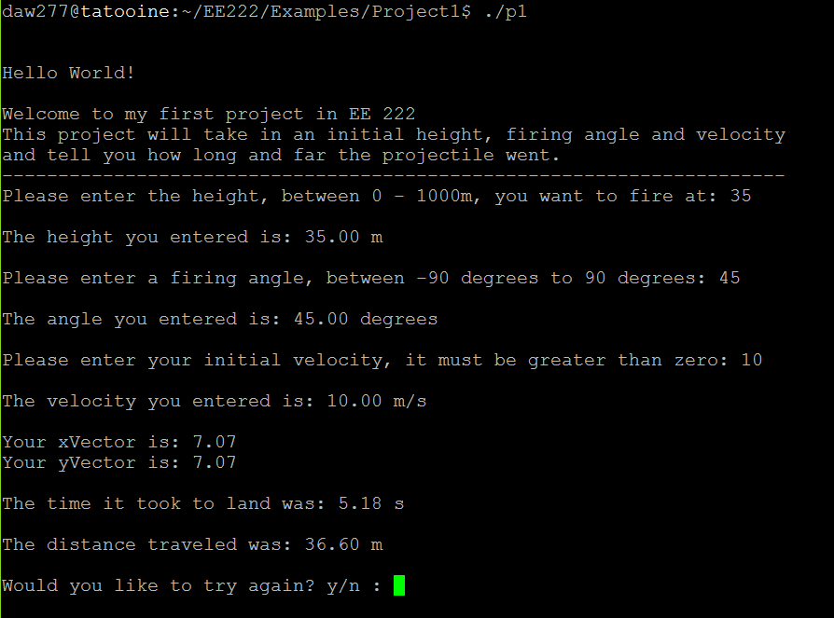

These are photos of each parameter failing:

Height:

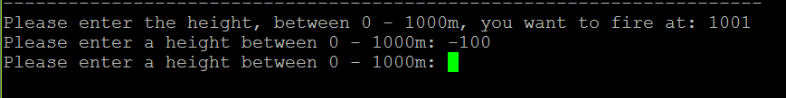

Firing Angle:

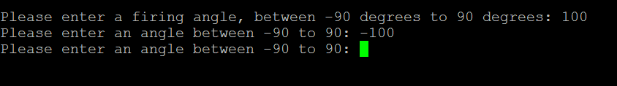

Initial Velocity:

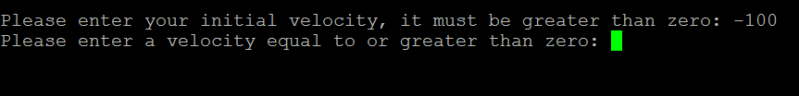

Conclusion:

In conclusion, this was a rather easy lab. I did not have very many difficulties. The only problem I ran into was getting the program to loop to redo the entire program again. Although that was not even required I added it anyway.